NAME: VIJAY VARSITH I

ROLL No.:241901125

EXPERIMENT 7

PERFORM WEB APPLICATION RECONNAISSANCE USING VARIOUS TOOLS

AIM:
To gather information about the structure, technologies, and possible entry points of a target web application before testing it for vulnerabilities.

THEORY:
Web application reconnaissance is different from web server reconnaissance (Experiment 5/6) — here the focus shifts from the underlying server software to the application itself: its pages, input forms, cookies, technologies (frontend/backend frameworks), and how users interact with it.
Key things to look at:
- Application technology stack (PHP, ASP.NET, Node.js, React, etc.)
- Login forms, search boxes, and file upload forms (common attack surfaces)
- Cookies set by the application and their security flags (HttpOnly, Secure)
- Client-side JavaScript files (may contain API endpoints or hardcoded secrets)
- Error messages (verbose errors can reveal backend details)

TOOLS REQUIRED
- Burp Suite (Community Edition) — for intercepting and inspecting traffic
- WhatWeb / Wappalyzer browser extension
- Web browser Developer Tools
- Target: DVWA or OWASP Juice Shop

PROCEDURE:

Step 1: Identify the Technology Stack
Run WhatWeb against the application:
whatweb http://<target-ip>/dvwa

Note the CMS/framework, programming language, and any JavaScript libraries detected
(older library versions are worth noting for later vulnerability checks).

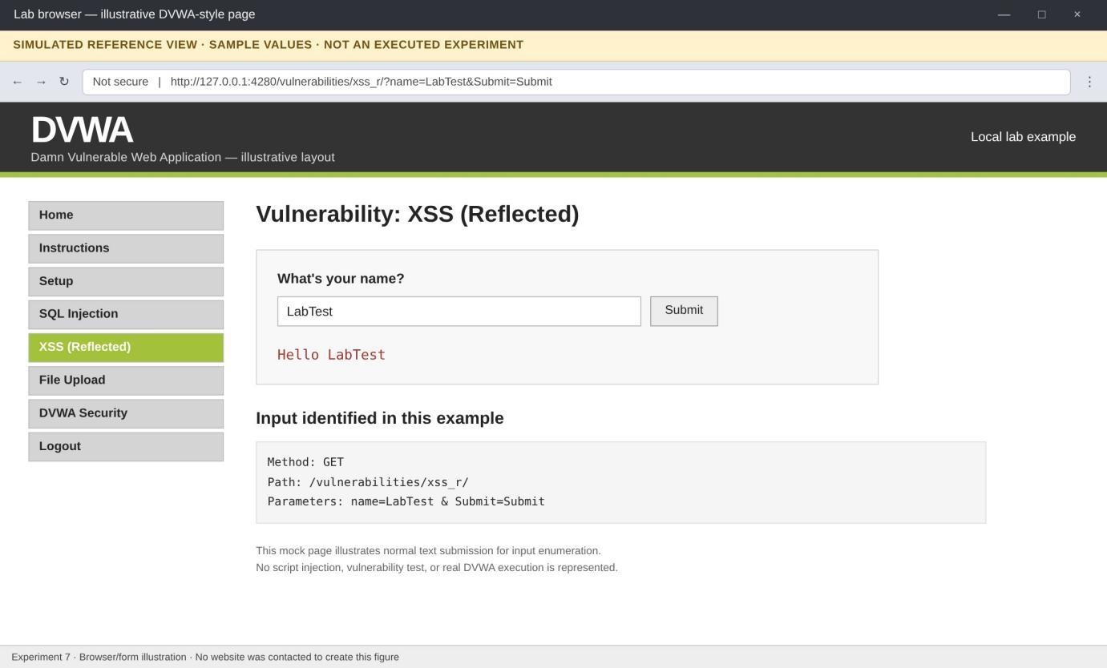
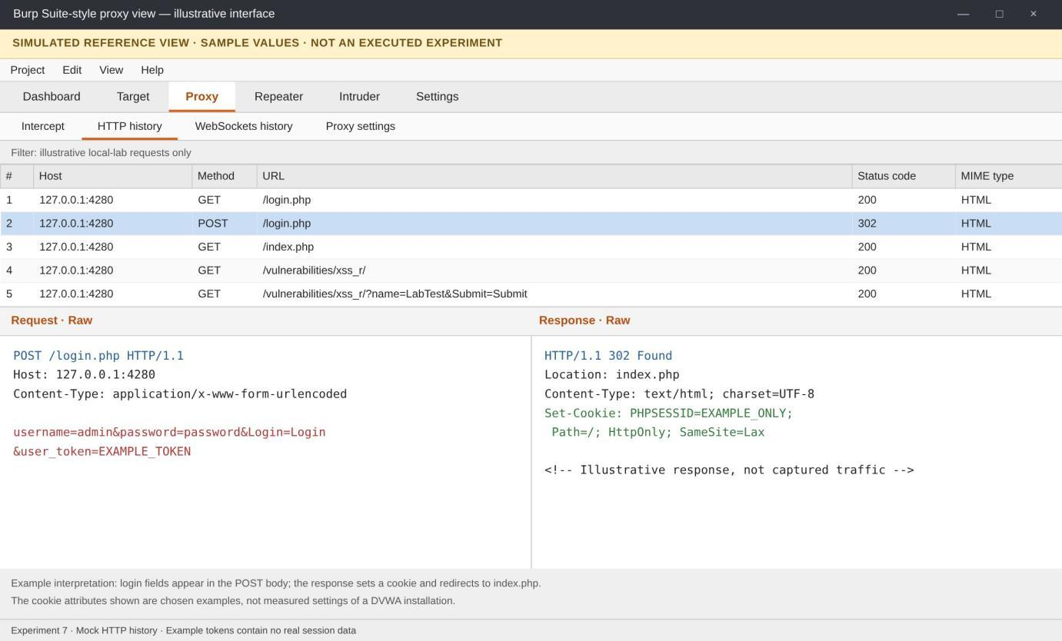
Fig. 1: Application form and input parameters (simulated reference).

Fig. 2: HTTP request and cookie inspection (simulated reference).

Step 2: Set Up Burp Suite as a Proxy
- Open Burp Suite → go to the Proxy tab → make sure "Intercept" is set up on
127.0.0.1:8080.
- In Firefox, set the network proxy to 127.0.0.1, port 8080 (Settings → Network Settings → Manual proxy).
- Browse to the target application through Firefox; Burp will now capture every request/response.

Step 3: Explore the Application Manually While Capturing Traffic
Click through the target application (login page, search box, profile page) while Burp's HTTP History tab records every request. Look for:
  - Hidden form fields (<input type="hidden">)
  - Parameters passed in the URL (e.g., ?id=3)
  - Any API calls made in the background (visible as JSON requests/responses)

Step 4: Inspect Cookies
In Burp's HTTP History, click on any request/response pair and check the Set-Cookie
header. Note whether flags like HttpOnly and Secure are present:
Set-Cookie: PHPSESSID=abc123; path=/

Missing HttpOnly means the cookie can be read by JavaScript (relevant for XSS-based session theft, covered in Experiment 12).

Step 5: Review Client-Side JavaScript Files
In the browser Developer Tools → Sources/Debugger tab, open each .js file loaded by the page and search for:
  - Hardcoded API keys or URLs
  - Comments left by developers
  - Hidden/unused endpoints not linked anywhere on the visible site

Step 6: Trigger and Study Error Messages
Enter unexpected input into a form field (e.g., a single quote ' in a search box) and observe the error message returned. A verbose error like a full SQL error string can reveal the backend database type - useful information for later testing .

OUTPUT:
A structured recon report of the web application: technology stack used, all discovered input points (forms/parameters), cookie security flags, and any information leaked through JavaScript files or error message

